CIF Los Angeles City Section

SATURDAY, July 13, 2013
UCLA – Pauley Pavilion, Club
CIF LA City Section Football Coaches Meeting / LAFCA Meeting

MEETING AGENDA

Sign-In (Coffee & Donuts) 8:00 – 8:30
- Visit vendor tables
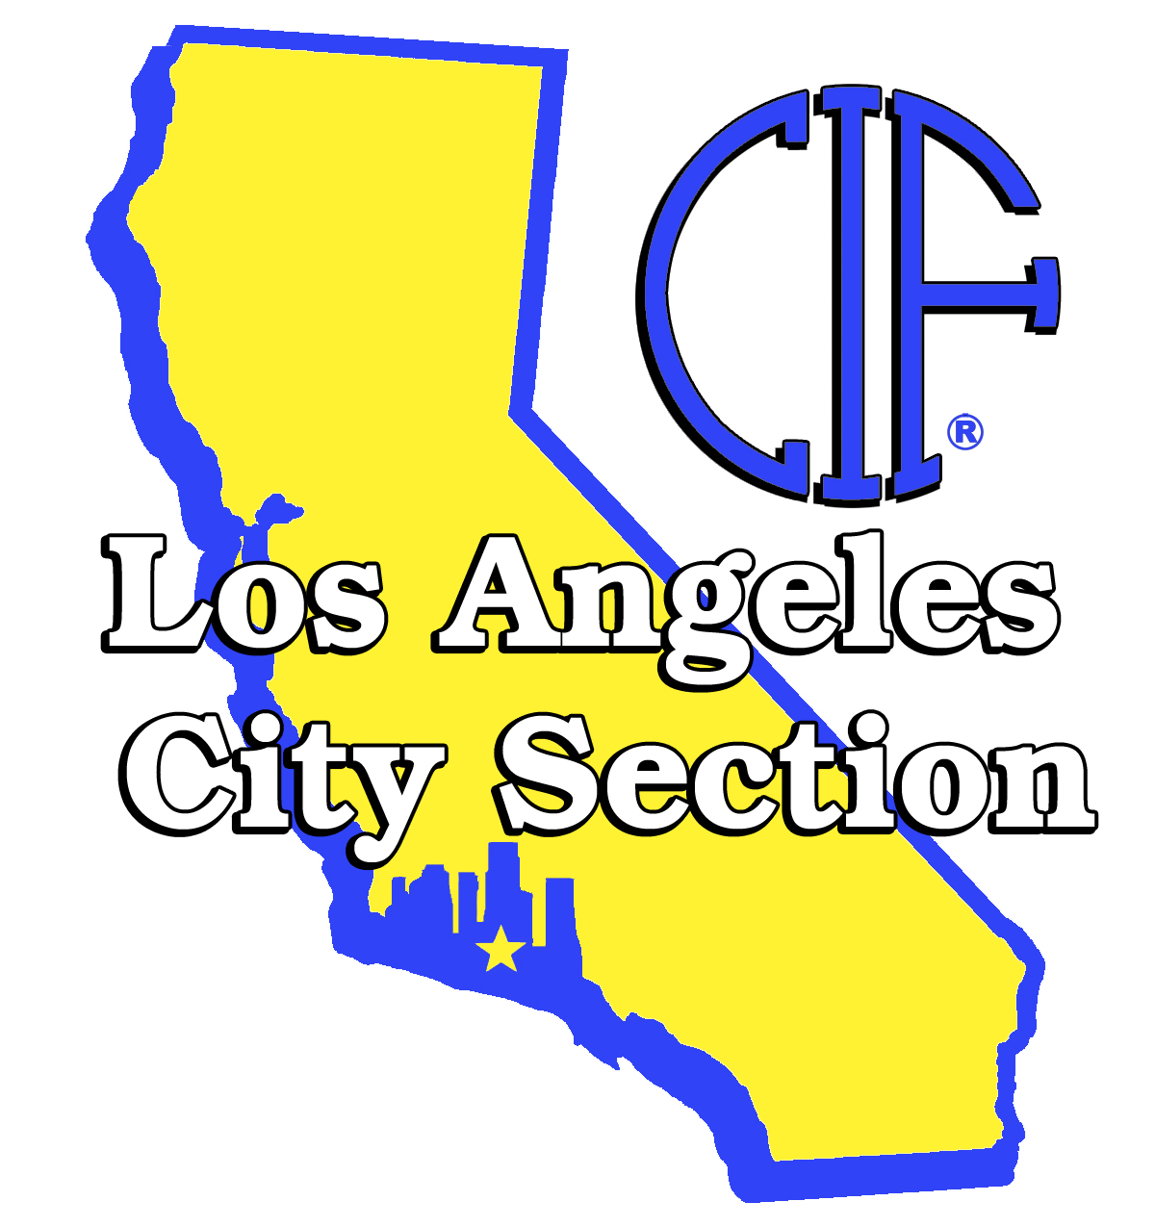
  - Donuts & Coffee provided by Sports Scholarship USA

League & Region Meeting – Pavilion Club - Head Coaches 8:30 – 9:00
- Seeding Committee Representative Selection
- League Rep Vote
- Confirm league schedules

Welcome & Introductions – Pavilion Club 9:00 – 9:05
- Results of Regional seeding representatives & league rep votes

Guest & Sponsors Introduction 9:05 – 9:15
Presenting Sponsor – Schutt Sports

General Session
Concussion Symptoms, precautions and protocol
Dr. Bornstein, MD 9:15 – 10:00
CIF Los Angeles City Section
John Aguirre – Commissioner 10:00 – 10:45
LA Football Officials Association 10:45 – 11:00
2012 Rule Changes & Review

Presenting Sponsor
Schutt Sports – Helmet Inspection and Reconditioning 11:00 – 12:00
Jeff Engle, Schutt Equipment - Helmet Inspection, Sanitation & Reconditioning

LA Football Coaches Association Meeting 12:00 – 12:15
Association Status
Awards

LAUSD Presentation
Trent Cornelius, Athletics Coordinator, LAUSD 12:15 – 12:45

